Emergency Shelter Housing Inventory Count:
Sacramento CoC: 2020 - 2023

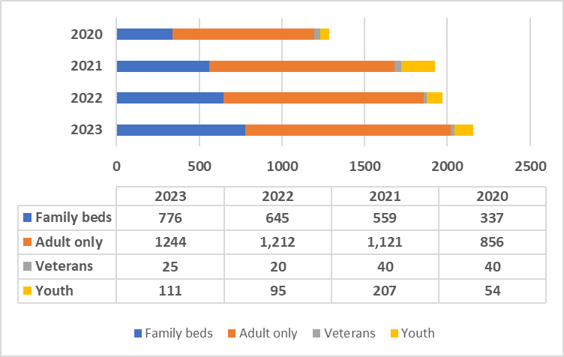
Source: CoC Housing Inventory Count Reports - HUD Exchange

