TRENDS IN HOMELESSNESS; SHELTER AND HOUSING: SACRAMENTO CoC:
2018 – 2023
SOURCE: Housing & Urban Development: CoC Homeless Population Report & Housing Inventory Count
Note: 2021 data is missing due to the pandemic

SUMMARY TABLE: Homeless Trends & Shelter & Permanent Supportive Housing [PSH] Trends: 2018 - 2023

Homelessness | % Increase from 2018 to 2023
# Unhoused | 156%
% Unsheltered | 27%
# Chronically homeless | 290%
# Serious Mentally Ill | 162%
# Substance Use | 154%
# Women | 167%
# Men | 148%
# People of Color | 172%

Shelter & Housing | % Increase | % Decrease
Total Shelter Beds | 30.5%
Seasonal Beds |  | 56.3%
PSH | 31.3%
Rapid Rehousing | 27.5%

The number of unhoused people in all categories [chronically homeless; serious
mental health issues; substance use; gender and people of color] has increased an average
6 times the increase in the number of shelter beds; PSH and rapid rehousing units
from 2018 - 2023

SUMMARY CHARTS:

Total Number Homeless & Unsheltered: 2018 – 2023
156% Increase from 2018 - 2023
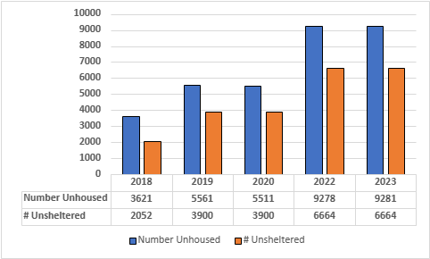

% Unsheltered: 2018 – 2023
27% Increase from 2018 - 2023

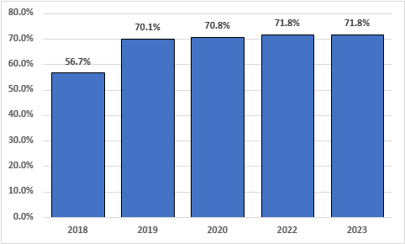

Total Number Chronically Homeless: 2018 – 2023
290% Increase from 2018 - 2023

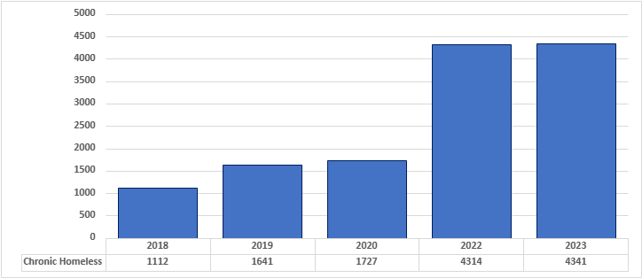

% Chronically Homeless Unsheltered & % of Total Homeless: 2018 – 2023
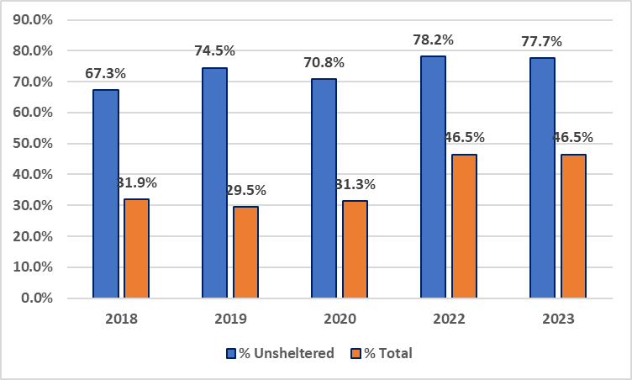

Total Number with Serious Mental Illness [SMI]: 2018 – 2023
162% Increase from 2018 - 2023

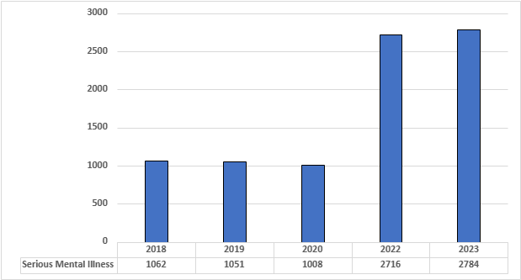

% SMI Unsheltered and % of Total: 2018 – 2023
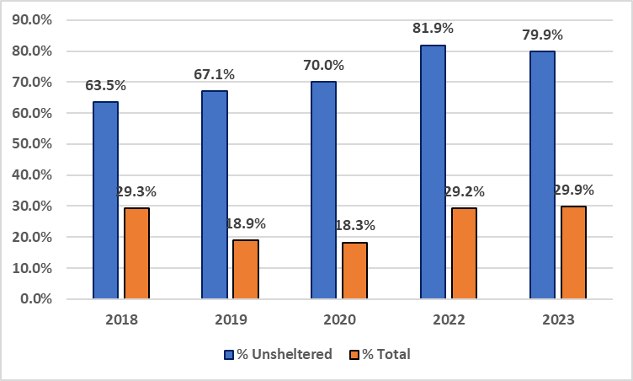

Total Number with Substance Use Issues: 2018 – 2023
154% Increase from 2018 - 2023
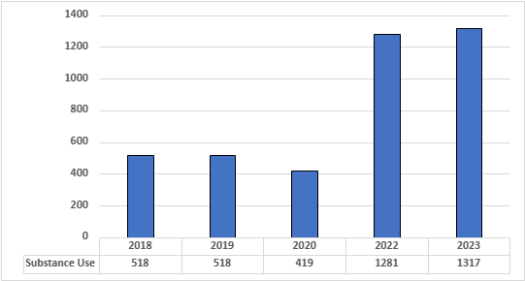

% Substance Use Unsheltered & % Total: 2018 – 2023
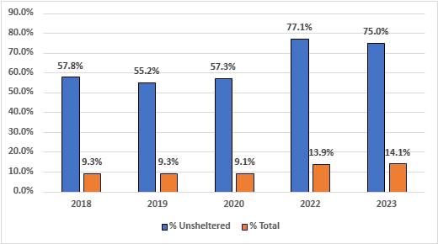

Number of Homeless Women & Men: 2018 – 2023
167% Increase for Homeless Women from 2018 – 2023
148% Increase for Homeless Men from 2018 - 2023

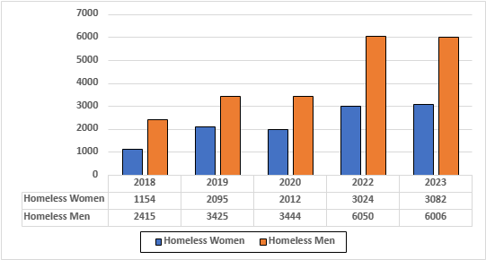

Homeless Women: % Unsheltered & % Total: 2018 – 2023
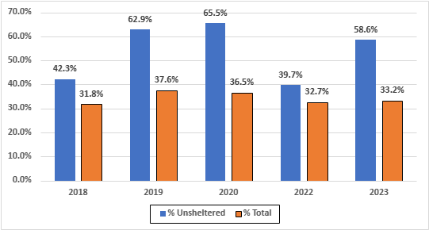

Homeless Men: % Unsheltered & % Total: 2018 - 2023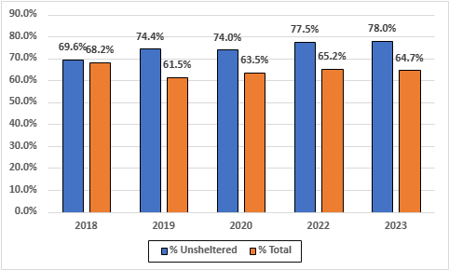

Number of Homeless People of Color: 2018 – 2023
172% Increase from 2018 - 2023

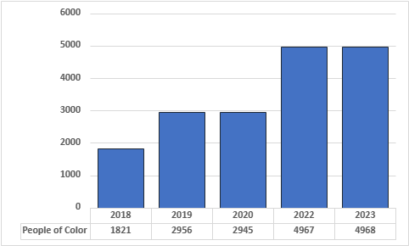

Homeless People of Color: % Unsheltered & % Total
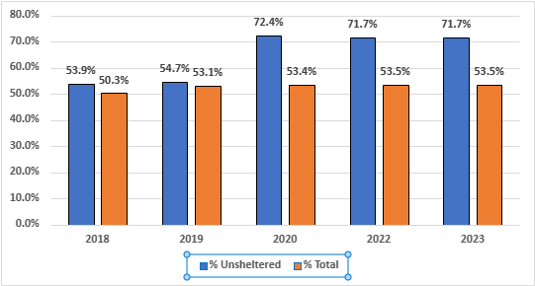

Shelter; Permanent Supportive Housing [PSH] & Rapid Housing: 2018 – 2023
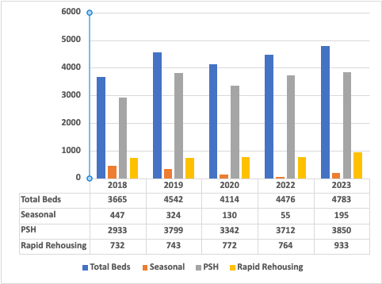
Total Shelter Beds: 30.5% Increase from 2018 – 2023
Seasonal beds: 56.3% Decline from 2018 – 2023
PSH: 31.3 Increase from 2018 – 2023
Rapid Rehousing Units: 27.5% Increase from 2018 - 2023

