SACRAMENTO EDUCATION & HOMELESS YOUTH 2023 FACT SHEET
Source: CA Homeless Youth Project Data Dashboard:
https://experience.arcgis.com/experience/60b83bb118ca497eba536e29d78a5f7b/page/Youth-Homelessness-Dashboard/

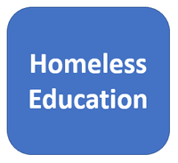
Student Homelessness in Sacramento CoC: 2022
Total homeless students enrolled: 10,064 or 3.85% of student body

 | California | Sacramento CoC
Suspension rate | 4.8% | 10%
Chronic Absenteeism | 34% | 60%
Graduation rate | 84% | 65%
UC/CSU Ready | 46% | 19%

Living Situation

Ethnicity

