The Myth of Unhoused Neighbors Refusing Services
City – County Outreach Teams: 2% Refusal Rate: May – Sept 2023
Compared to 99% Refusal Rate Reported by Sheriff’s in 7/23
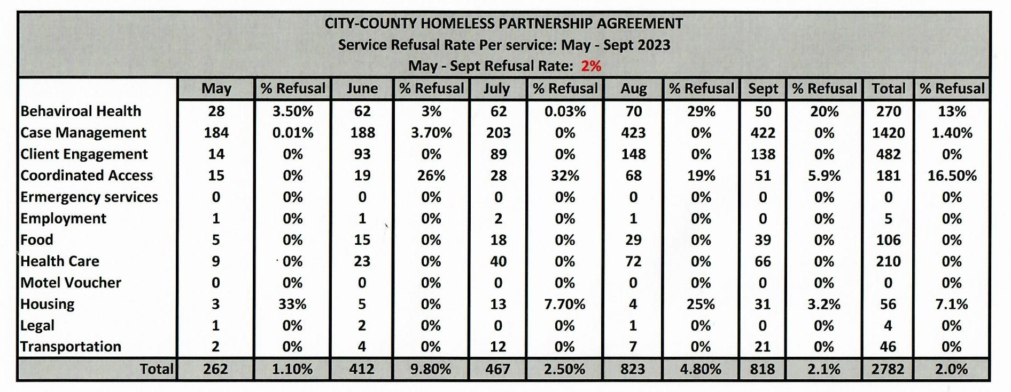
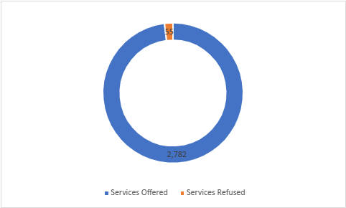

MAKING THE CASE FOR TRAUMA INFORMED CARE
OUTREACH AND ENGAGEMENT
PEOPLE WILL ACCEPT SERVICES IF OFFERED BY NON-LAW ENFORCEMENT OUTREACH TEAMS

