**SUBSTANCE USE FACT SHEET**

**SACRAMENTO COUNTY: 2023**

**Homeless Deaths of Substance Use Overdoses: 2015 – Mid-2022**

***The Rise of Methamphetamine Overdose Deaths***

|  |  |  |  |  |  |  |
| --- | --- | --- | --- | --- | --- | --- |
| **Year** | **Substance Use Overdoses** | **Methamphetamine Overdoses** | **Total Homeless Deaths** | **% Substance Use of all deaths** | **% Meth of all deaths** | **% Meth of Substance Use deaths** |
| **2015** | **21** | **12** | **78** | **27%** | **15.4%** | **57.1%** |
| **2016** | **20** | **15** | **71** | **28.2%** | **21.1%** | **75%** |
| **2017** | **45** | **27** | **124** | **36.3%** | **21.8%** | **60%** |
| **2018** | **40** | **34** | **132** | **30.3%** | **25.8%** | **85%** |
| **2019** | **59** | **43** | **138** | **42.8%** | **31.2%** | **72.8%** |
| **2020** | **58** | **46** | **137** | **42.3%** | **33.8%** | **79.3%** |
| **2021** | **98** | **78** | **199** | **49.2%** | **39.2%** | **79.6%** |
| **2022 [1st 6 months]** | **46** | **36** | **93** | **49.5%** | **38.8%** | **78.3%** |
| **Total** | **387** | **291** | **972** | **40.8%** | **29.9%** | **75.2%** |

As documented by SRCEH in our annual homeless deaths reports since 2015, 972 people experiencing homelessness have died, 387 or 40% of whom by substance use overdoses. Of this total, 291 homeless people or 75% died by methamphetamine overdose. These deaths were disproportionately people of color, black and indigenous people experiencing homelessness. The table below documents these deaths from 2015 – 2022, documenting the overall rise in people experiencing homeless dying of overdose, and the rise of methamphetamine overdose as a percentage of substance use deaths

**Sacramento County Opioid Epidemic**

***Source: CA Department of Public Health: CA Overdose Surveillance Dashboard***

|  |  |  |
| --- | --- | --- |
| ***Opioid Overdose Deaths*** | **57 in 2019**  **Increase from 47 in 2017** |  |
| **Opioid Prescriptions** | **14% decrease in 2018 –**  **38.2 per 100,000** |  |
| **Deaths from synthetic drugs** | **51% increase in 2018** |  |
| **Emergency Room visits** | **359 in 2018**  **Increase from 241 in 2016** |  |

**Opioid-Related Overdose Deaths by Age: 2021**

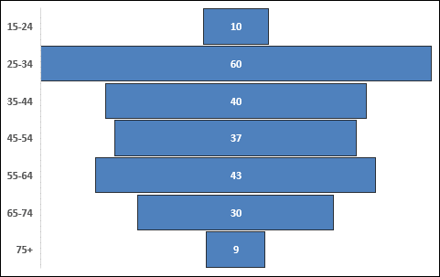

**Opioid-Related Overdose by Ethnicity: 2021**

**Methamphetamine [Meth] & Fentanyl Overdose Deaths: 2021**

|  |  |
| --- | --- |
| **205** | **Meth-Involved Deaths** |
| **116** | **Fentanyl-Involved Deaths** |
| **50** | **Combination of Meth & Fentanyl** |